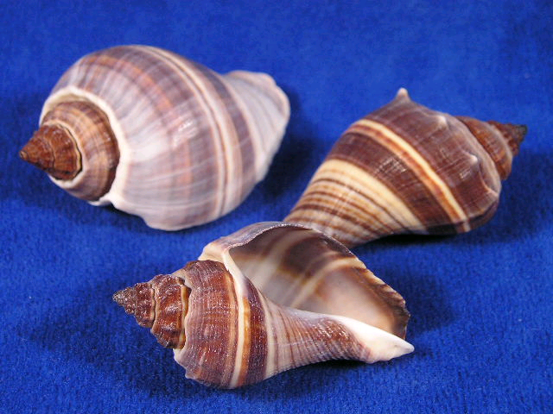

She sells seashells
by the seashore.
The shells she sells are surely seashells.


